**Breast Cancer Analysis using Support Vector Machines (SVM)**

**Introduction**

Breast cancer remains a significant global health concern, necessitating advanced diagnostic tools for early detection and effective treatment. Machine learning, specifically Support Vector Machines (SVM), has emerged as a promising avenue in contributing to the diagnosis of breast cancer. In this comprehensive analysis, we delve into the intricacies of the Breast Cancer Wisconsin dataset, utilizing SVM to discern intricate patterns and deepen our understanding of tumor characteristics.

**Dataset Overview**

The Breast Cancer Wisconsin dataset, a cornerstone in cancer research, provides a wealth of information derived from digitized images of fine needle aspirates (FNAs) of breast masses. Comprising 569 samples, each characterized by 30 features, the dataset includes critical metrics such as mean radius, mean texture, mean perimeter, mean area, mean smoothness, and others. The target variable distinguishes between malignant (1) and benign (0) diagnoses.

**Exploring the Dataset**

The dataset is a set of 569 samples each with 30 features, which provides an in-depth picture?of fine needle aspiration (FNA) from breast masses. These features cover a wide range of morphological characteristics obtained from digitized images that serve to shed light on the complexity of breast cancer details.

The investigation sought to establish the nature of data and importance. To determine the significance of feature names concerning breast cancer diagnosis, these were examined closely. The morphological traits obtained from the breast mass images form the underpinning of this subsequent deep analysis. Detailed analysis of these traits is critical for building a sophisticated understanding not only on the data set but also on future analytical procedures that might be conducted.

**Data Visualization**

Cancer diagnostics, particularly in breast cancer, involves the analysis of multiple morphological characteristics extracted from digitized images. Visualization acts as a lens through which we can unravel patterns, trends, and potential insights that may not be immediately apparent in raw data. By translating numerical values into visual representations, we aim to uncover meaningful relationships and discernible trends within the dataset.

* **Diverse Set of Plots**
* The choice of a diverse set of plots, including pairplots, scatter plots, violin plots, box plots, and swarm plots, is strategic and aligns with the project's objective. Each type of plot brings a unique perspective to the data, facilitating a multi-faceted exploration of its intricacies.
* **Pairplot: A Holistic View**

The pairplot, employed in our analysis, provides a holistic view of feature interrelationships. This type of plot enables us to visualize pairwise relationships between multiple features simultaneously. For breast cancer diagnostics, understanding how different morphological characteristics correlate or interact with each other is essential. The pairplot serves as a visual summary, offering a comprehensive overview of potential patterns and correlations.

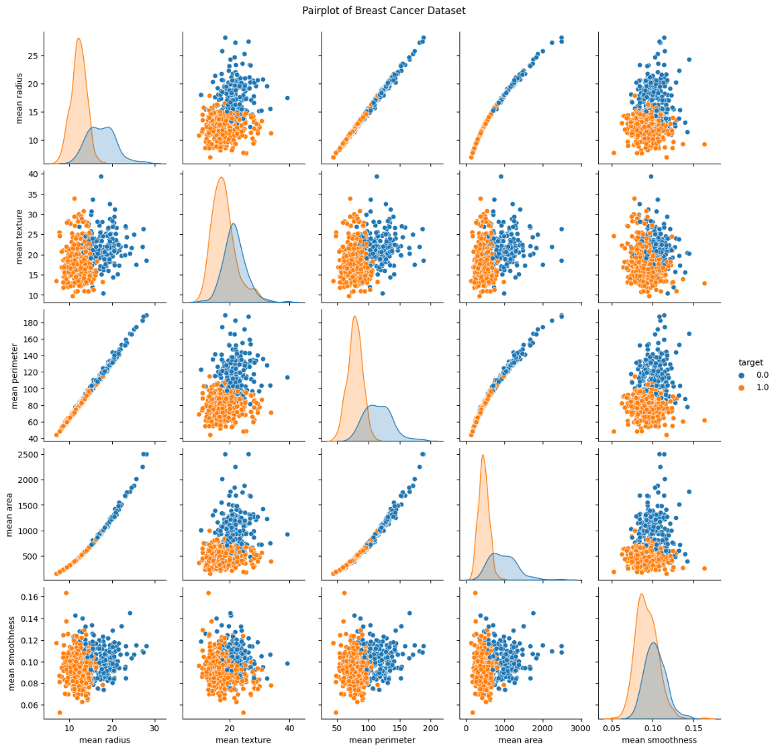

* **Scatter Plots: Zooming In on Associations**

While the pairplot provides a broad view, scatter plots allow us to zoom in on specific associations between features, especially concerning malignant and benign tumors. By plotting individual data points on a two-dimensional space, scatter plots reveal clusters, trends, and potential outliers. This level of granularity is invaluable in identifying specific morphological characteristics that may exhibit distinctive patterns for different tumor types.

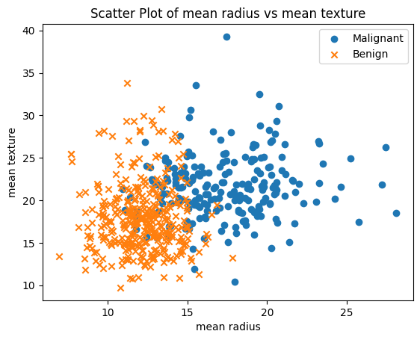

* **Violin and Box Plots: Unveiling Distributions**

Violin and box plots complement the exploration by unveiling the distributions of features. For cancer diagnostics, understanding the distribution of morphological characteristics for malignant and benign tumors is crucial. These plots provide insights into the central tendency, spread, and potential asymmetry of the data, aiding in the identification of discriminatory features.

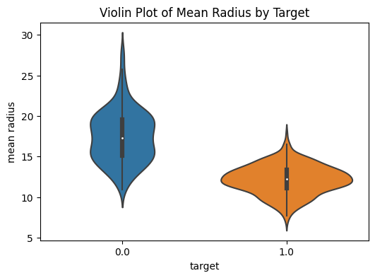

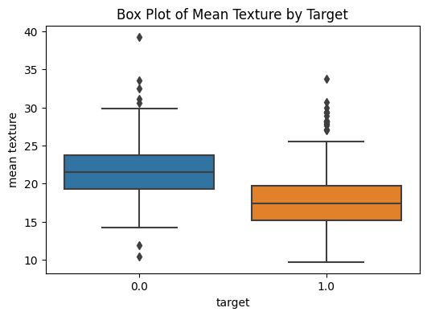

* **Swarm Plots: Adding Precision**

Swarm plots, a more detailed visualization technique, add precision by depicting individual data points along with the distribution. This nuanced approach allows for a closer inspection of the data, particularly in regions where features may overlap or exhibit intricate patterns.

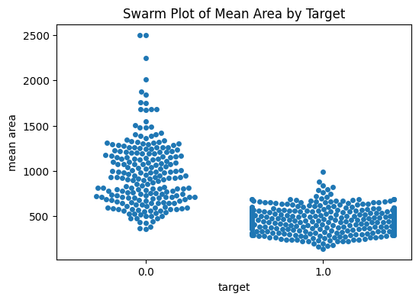

**Model Training and Evaluation**

**Data Preprocessing**

The preprocessing phase involves a meticulous division of the dataset into training and testing sets, with 80% of the data allocated for training and 20% for testing. This strategic split lays the groundwork for robust model assessment and validation.

**Support Vector Machines (SVM)**

SVM, recognized for its versatility in handling both linear and non-linear relationships in data, is employed to construct the model. Leveraging the SVC implementation from scikit-learn, the SVM model is tailored to the intricate nature of cancer datasets, promising accurate and reliable predictions.

**Model Evaluation**

The crux of the analysis lies in the evaluation of the trained SVM model on the test set. Performance metrics, including precision, recall, F1-score, and support, are encapsulated in a detailed classification report. This report not only quantifies the accuracy of the model but also provides a nuanced breakdown of its effectiveness in distinguishing between malignant and benign tumors.

**Conclusion**

In conclusion, the utilization of SVM in the Breast Cancer Wisconsin dataset arises as an effective and reliable tool for cancer detection. The analysis is an integrative journey which starts from data exploration and visualization, proceeds to model training and assessment, before terminating in personalized forecasting. The SVM model is demonstrated to be highly accurate in differentiating malignant and benign tumors, indicating its possible application as a cancer diagnostic tool.

The report does not only focus on the successes but describes a path for future research. The suggested approaches include parameter tuning, feature engineering, and trying other machine learning algorithms. The iterative refinement of models and methodologies reinforces the interest in developing machine learning to improve cancer diagnosis.